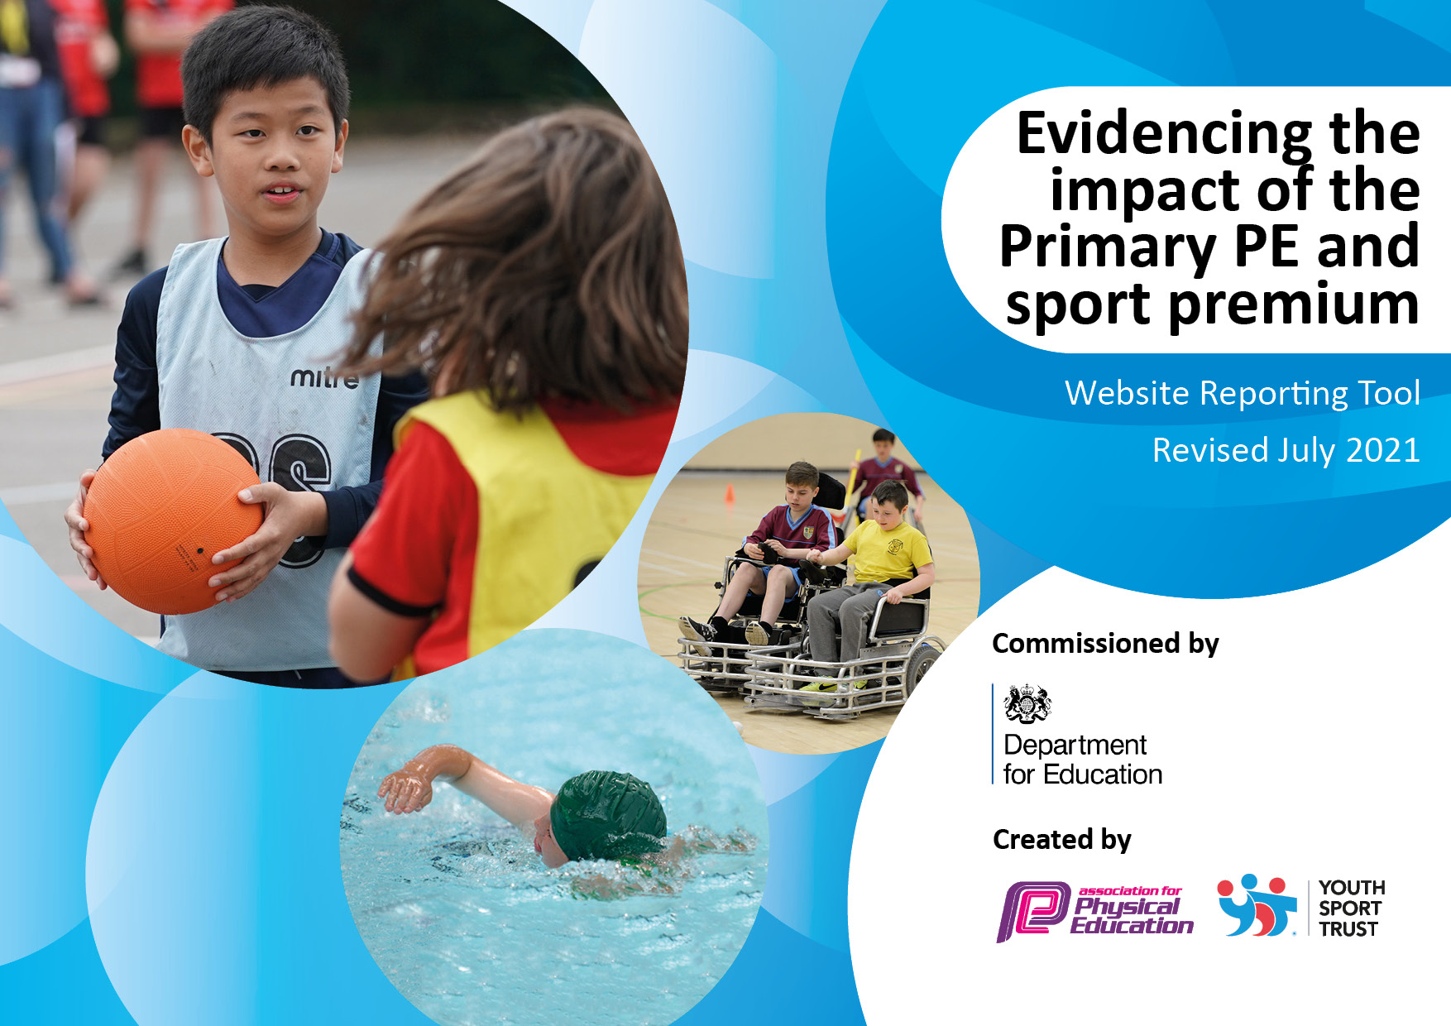
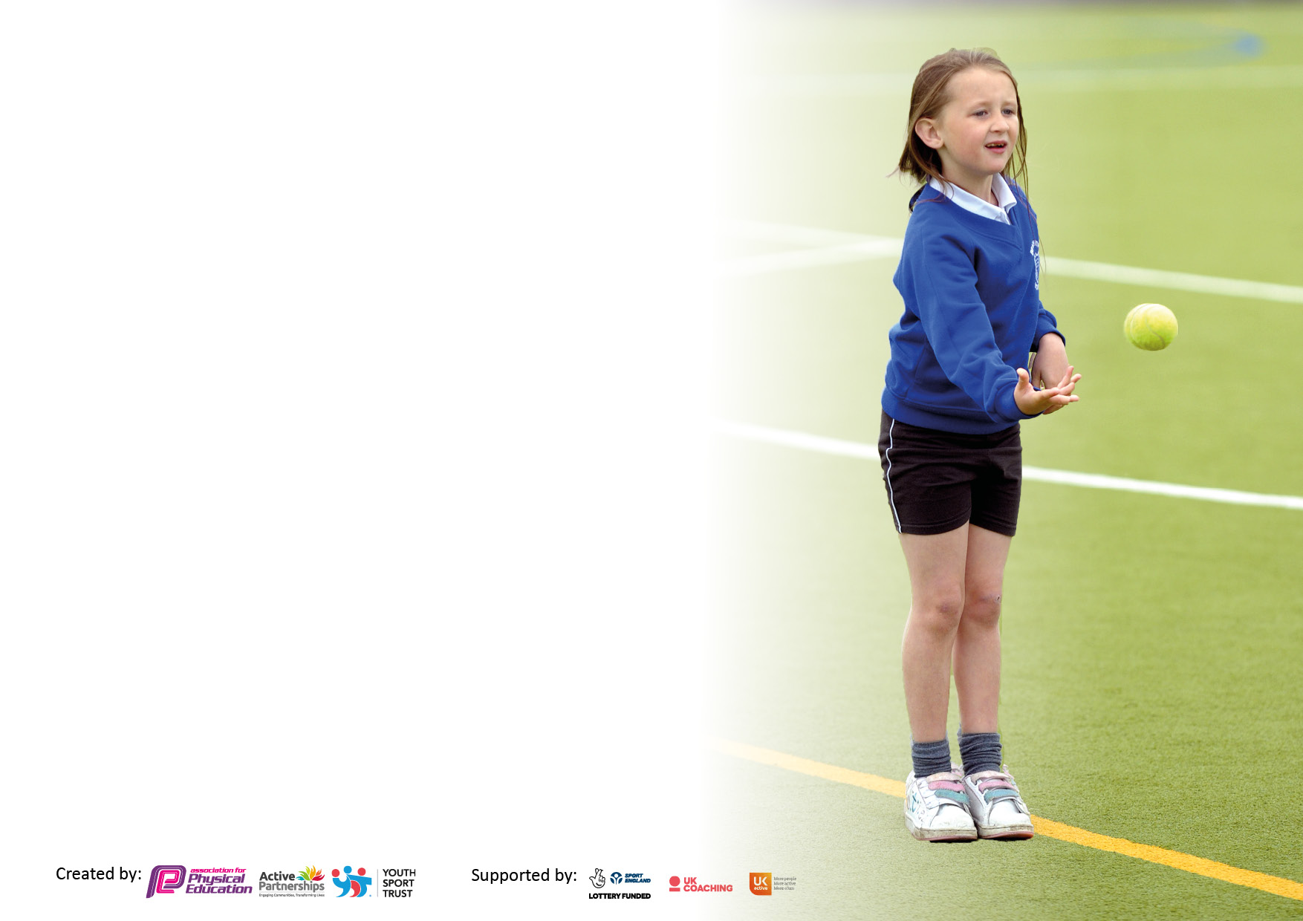

It is important that your grant is used effectively and based on school need. The Education Inspection Framework makes clear there will be a focus on ‘whether leaders and those responsible for governors all understand their respective roles and perform these in a way that enhances the effectiveness of the school’.

Under the Quality of Education Ofsted inspectors consider:
Intent - Curriculum design, coverage and appropriateness
Implementation - Curriculum delivery, Teaching (pedagogy) and Assessment
Impact - Attainment and progress

To assist schools with common transferable language this template has been developed to utilise the same three headings which should make your plans easily transferable between working documents.

Schools must use the funding to make additional and sustainable improvements to the quality of Physical Education, School Sport and Physical Activity (PESSPA) they offer. This means that you should use the Primary PE and sport premium to:

- Develop or add to the PESSPA activities that your school already offer
- Build capacity and capability within the school to ensure that improvements made now will benefit pupils joining the school in future years
- The Primary PE and sport premium should not be used to fund capital spend projects; the school’s budget should fund these.

Pleasevisitgov.ukfortherevisedDfEguidanceincludingthe5keyindicatorsacrosswhichschoolsshoulddemonstrate animprovement.Thisdocumentwillhelpyoutoreviewyourprovisionandtoreportyourspend.DfEencouragesschools to use this template as an effective way of meeting the reporting requirements of the Primary PE and sport premium.

We recommend you start by reflecting on the impact of current provision and reviewing the previous spend.

Schools are required to publish details of how they spend this funding, including any under-spend from 2019/2020, as well as on the impact it has on pupils’ PE and sport participation and attainment. All funding must be spent by 31st July 2022.

We recommend regularly updating the table and publishing it on your website throughout the year. This evidences your ongoing self-evaluation of how you are using the funding to secure maximum, sustainable impact. Final copy must be posted on your website by the end of the academic year and no later than the 31st July 2021. To see an example of how to complete the table please click HERE.
Created by: Supported by:

Details with regard to funding
Please complete the table below.

Total amount carried over from 2019/20 | £0
Total amount allocated for 2020/21 | £17,790
How much (if any) do you intend to carry over from this total fund into 2021/22? | £9,522
Total amount allocated for 2021/22 | £17,790
Total amount of funding for 2021/22. To be spent and reported on by 31st July 2022. | £27,312
Swimming Data
Please report on your Swimming Data below.

Meeting national curriculum requirements for swimming and water safety.

N.B. Complete this section to your best ability. For example you might have practised safe self-rescue techniques on dry land which you can then transfer to the pool when school swimming restarts.
Due to exceptional circumstances priority should be given to ensuring that pupils can perform safe self rescue even if they do not fully meet the first two requirements of the NC programme of study
What percentage of your current Year 6 cohort swim competently, confidently and proficiently over a distance of at least 25 metres?  N.B. Even though your pupils may swim in another year please report on their attainment on leaving primary school at the end of the summer term 2021.  Please see note above | 90%
What percentage of your current Year 6 cohort use a range of strokes effectively [for example, front crawl, backstroke and breaststroke]?  Please see note above | 80%
What percentage of your current Year 6 cohort perform safe self-rescue in different water-based situations? | 100%
Schools can choose to use the Primary PE and sport premium to provide additional provision for swimming but this must be for activity over and above the national curriculum requirements. Have you used it in this way? | No

Action Plan and Budget Tracking
Capture your intended annual spend against the 5 key indicators. Clarify the success criteria and evidence of impact that you intend to measure to evaluate for pupils today and for the future.

Academic Year: 2021/22 | Total fund allocated: | Date Updated:
Key indicator 1: The engagement of all pupils in regular physical activity – Chief Medical Officers guidelines recommend that primary school pupils undertake at least 30 minutes of physical activity a day in school |  |  |  | total allocation:
 |  |  |  | £6,787
Intent | Implementation |  | Impact
Your school focus should be clear what you want the pupils to know and be able to do and about  what they need to learn and to  consolidate through practice: | Make sure your actions to achieve are linked to your intentions: | Funding allocated: | Evidence of impact: what do pupils now know and what can they now do? What has changed?: | Sustainability and suggested next steps:
Utilising PE equipment to it maximum potential so that it can be accessed by all pupils | Replenishing sporting equipment and playtime resources - tennis balls, hockey stick, footballs and posts, cones, skipping ropes, balance boards, stilts | £6,787 | Pupils are introduced and able to use the equipment on a rota basis.  Pupils are engaged at break times in different physical activities. | Continue to maintain high quality of play and sport equipment by storing and accessing it effectively.
Key indicator 2: The profile of PESSPA being raised across the school as a tool for whole school improvement |  |  |  | total allocation:
 |  |  |  | £2,500
Intent | Implementation |  | Impact
Your school focus should be clear what you want the pupils to know and be able to do and about  what they need to learn and to  consolidate through practice: | Make sure your actions to achieve are linked to your intentions: | Funding allocated: | Evidence of impact: what do pupils now know and what can they now do? What has changed?: | Sustainability and suggested next steps:
Playtime leaders used to motivate, engage pupils to participate in active play during breaktimes | Focussing on multi sports, encouraging group engagement to all pupils. Key children identified and support to access and enjoy different activities. | £2,500 | Increase in number of pupils choosing to be involved in active play independently and with others. | Introduce a variety of different activities and ensure all pupils are involved.

Key indicator 3: Increased confidence, knowledge and skills of all staff in teaching PE and sport |  |  |  | total allocation:
 |  |  |  | £1,747
Intent | Implementation |  | Impact
Your school focus should be clear | Make sure your actions to | Funding | Evidence of impact: what do | Sustainability and suggested
what you want the pupils to know | achieve are linked to your | allocated: | pupils now know and what | next steps:
and be able to do and about | intentions: |  | can they now do? What has
what they need to learn and to |  |  | changed?:
consolidate through practice:
Professional learning for staff on physical literacy lead by PE Lead | Meeting with PE Lead and support on planning.  Membership of Active Surrey.  Access to online resources Getset4PE | £ £1,747 | Staff expressed increased confidence in knowledge, skills and supported by resource. | Maintain CPD opportunities for staff.
Key indicator 4: Broader experience of a range of sports and activities offered to all pupils |  |  |  | total allocation:
 |  |  |  | £16,445
Intent | Implementation |  | Impact
Your school focus should be clear | Make sure your actions to | Funding | Evidence of impact: what do | Sustainability and suggested
what you want the pupils to know | achieve are linked to your | allocated: | pupils now know and what | next steps:
and be able to do and about | intentions: |  | can they now do? What has
what they need to learn and to |  |  | changed?:
consolidate through practice:
Creating additional activity opportunities outside of school  Increase participation of active play at break and lunch times  Accessibility to sports venues who can offer facilities e.g hockey events, swimming lessons.  Introducing dance and movement as a physical activity | Pupils involved in inter school and district sporting events.  Cross country running  Access to specialised sports facilities e.g. hockey club.  Reconfigure and upgrade hard surface play areas to allow for team games such as netball, hockey, tennis  Facilitate travel to sports centres for training and participation  Upgrade hall facilities for projection and sound systems to access on line PE lessons. | £1,780  £6,198  £2,467  £6,000 | A wide range of pupils involved in different sports. Results achieved encourage greater ambition in the pupils.  Pupils access to large group activities. All year groups benefit from use.  Pupils engage in acquiring new skills.  Pupils movement and coordination skills development improved. | Create opportunities for even more sports next year broaden teams to extend opportunity to more pupils.  Maintain area allowing full and free flow access to play areas for all.  Maintain access for pupils to facilities not available at schoo  Monitor and maintain access

Key indicator 5: Increased participation in competitive sport |  |  |  | total allocation:
 |  |  |  | £400
Intent | Implementation |  | Impact
Your school focus should be clear | Make sure your actions to | Funding | Evidence of impact: what do | Sustainability and suggested
what you want the pupils to know | achieve are linked to your | allocated: | pupils now know and what | next steps:
and be able to do and about | intentions: |  | can they now do? What has
what they need to learn and to |  |  | changed?:
consolidate through practice:
Promote competitive opportunities for all pupils across the school  Ensure that all sports coaches and instructors engaged in providing after school sports clubs are quality assured. | Sports Day for both KS1 and KS2  Checks of DBS, insurance and policy are enforced. | £ 400 | Pupils recognise the wider benefits of participating in sport. Allows pupils to appreciate physical activity as an important part of their development.  The extra-curricular sport provision is high quality. | Continue to audit staffing for PE sport and activity.

Signed off by
Head Teacher: | Elizabeth Higgins
Date:
Subject Leader: | Christine McCarthy

