Ideas for writing activities.
Try to do an activity over 2 days to give you time to plan, write and then edit. Remember all we have talked about this year – checking for paragraphs, good sentence starts, imaginative vocabulary, spellings and punctuation (,.!”?() - …).

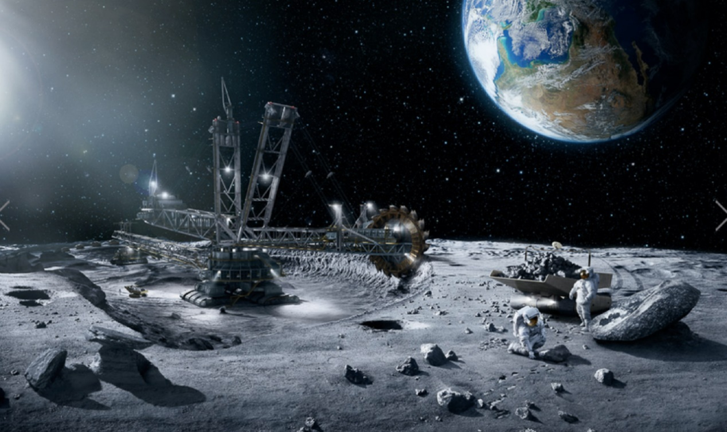

Story starter!
“Houston come in. Houston come in. This is Apollo 11. We have touched down on the surface of the moon. Over.”
“Apollo 11, this is Houston. You are clear to begin your mission. Over.”
Gazing around in a state of awe and wonder, the astronaut stood and admired what he saw. Outer space was a thing of pure beauty: a never-ending chasm of blackness, illuminated by stars that sparkled like beautiful diamonds.
He took a few steps forward, smiling at the joy of the feeling of weightlessness that never ceased to amaze him. Happy that his oxygen levels were high and his friends were close by, the astronaut set about his mission.
All seemed to be going well, but then the warning alarm on the ship sounded…
“Houston. Houston come in! Houston, we have a problem…” Can you continue the story of the Apollo mission to the moon?

- Write a diary entry as if you are Neil Armstrong and have landed on the Moon. What would you tell me about all you have done and seen and how you are feeling?

- Write a space poem and decorate it in neat. It could be about the planets or the Moon or even space travel.

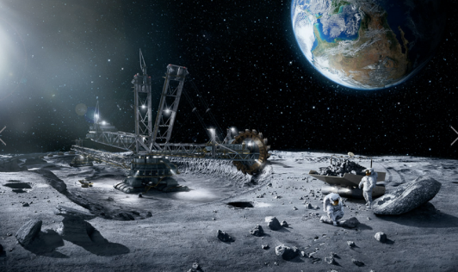

It is extremely expensive to send a man/woman into space. It is even more expensive and dangerous to send people to the moon: it hasn’t been attempted for many years. Do you think it is important that we try to understand more about space and the moon?
In the year 2013, 200’000 people from 140 different countries applied to take part in a special project: to become the first people to live on Mars in the year 2023. Do you think that living in space is something that might one day be considered ‘normal’? Is it something you would like to do? Can you make a list of reasons for/against living on Mars?

- We have been reading “Hatchet” by Gary Paulsen. Imagine you have crash landed in the wilderness. Tell me your own story of survival or a story about someone else who has crashed and what they did to survive.
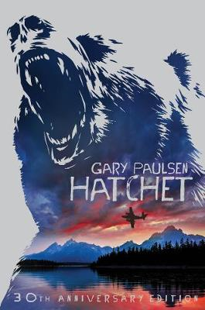

Good luck with these first pieces of writing. We were planning to do them in class so I am looking forward to seeing what you produce.

