Topic activities linked to “Space”

- Art - Van Gogh - Starry Night
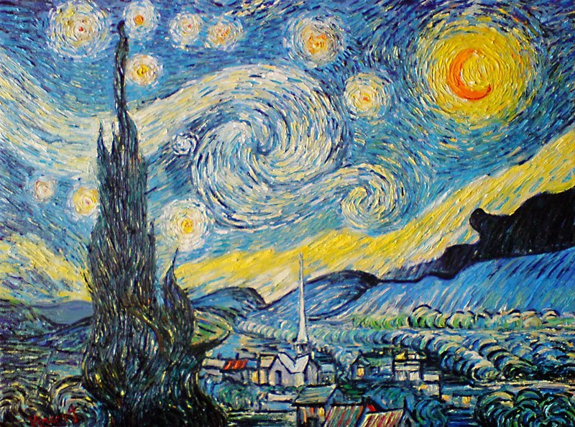

Try to recreate this picture yourself. Can you draw it as it is and then create your own version as well?
https://www.youtube.com/watch?v=FLNU6dPi93s This you tube clip tells you about the painting and helps you draw it step by step.

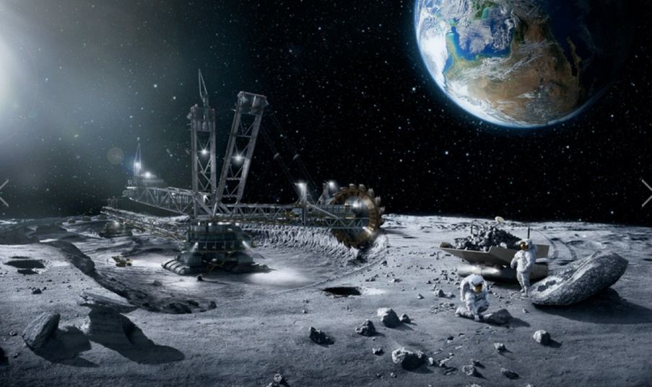
- Imagine you are exploring the surface of the moon as an astronaut. Can you draw what you might see?

- We made “Space” rock cakes but had to watch rather than doing the creating ourselves. Try to make them at home. Here is the recipe we used. They were yummy.

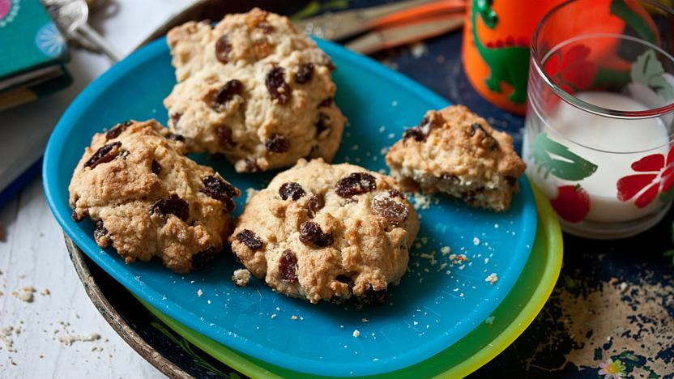

Ingredients
- 225g/8oz self-raising flour
- 75g/2½oz caster sugar
- 1 tsp baking powder
- 125g/4½oz unsalted butter, cut into cubes
- 150g/5½oz dried fruit
- 1 free-range egg
- 1 tbsp milk
- 2 tsp vanilla extract

Method
1.Preheat oven to 180C/160C Fan/Gas 4 and line a baking tray with baking parchment.
2.Mix the flour, sugar and baking powder in a bowl and rub in the cubed butter until the mixture looks like breadcrumbs, then mix in the dried fruit.
3.In a clean bowl, beat the egg and milk together with the vanilla extract.
4.Add the egg mixture to the dry ingredients and stir with a spoon until the mixture just comes together as a thick, lumpy dough. Add a teaspoon more milk if you need it to make the mixture stick together.
5.Place golfball-sized spoons of the mixture onto the prepared baking tray. Leave space between them as they will flatten and spread out to double their size during baking.
6.Bake for 15–20 minutes, until golden-brown. Allow to cool for a couple of minutes, then turn them out onto a wire rack to cool.

- Find out any other interesting facts that you can about Space or Space exploration and make a poster of things you didn’t know.

- Design and make you own space rocket

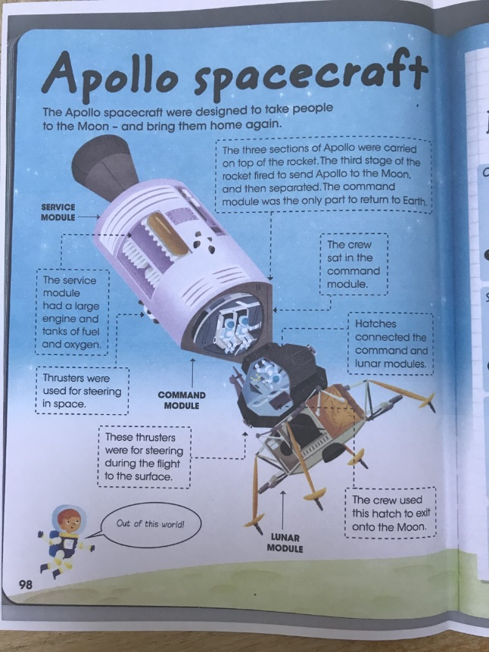
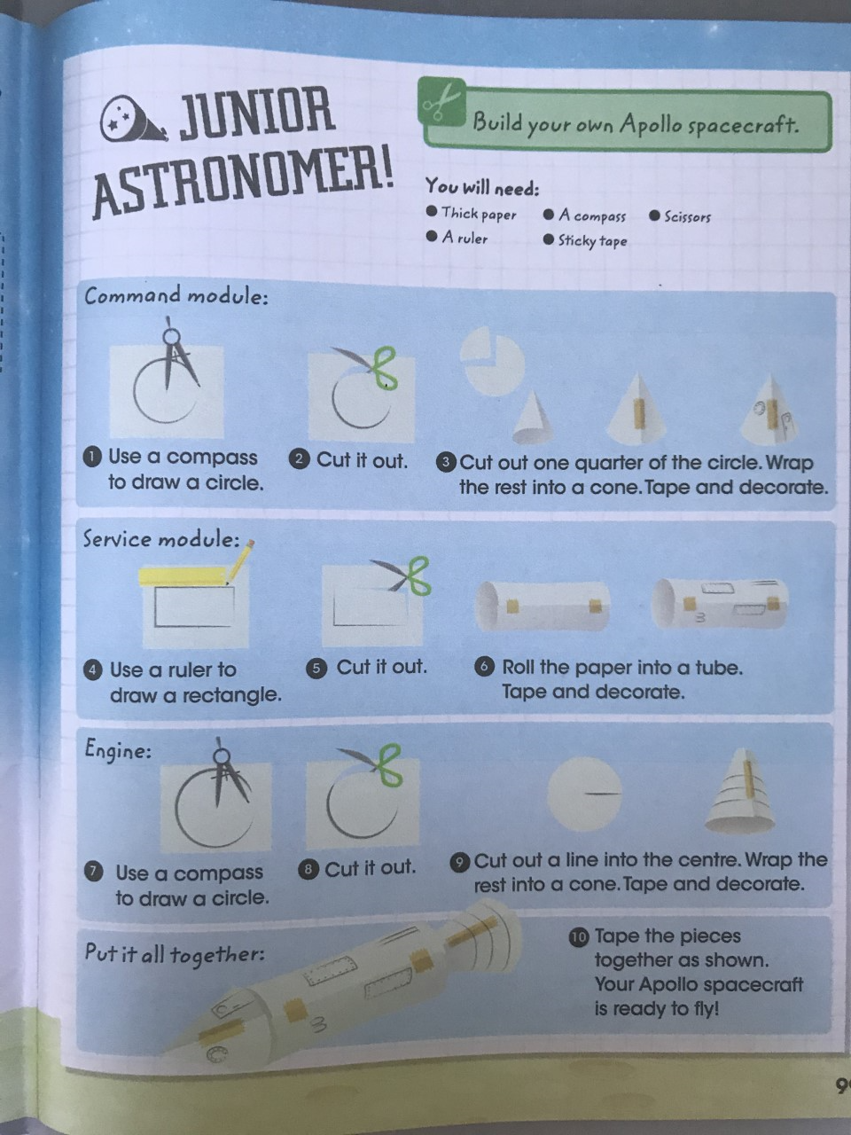
These were all things we were going to do in class. Good luck. Have a go with these fun topic inspired activities and I hope to see your finished pieces soon!

