Space Topic Final Activity
We have now completed all the work we were going to do on Space. We had a fun activity to finish the topic called Mission Control. You can still try it if you would like. You need to try and get a space rocket to travel to the space station across a room. You can only use – string, sellotape, a balloon, a straw (or similar tubing) and 2 chairs.

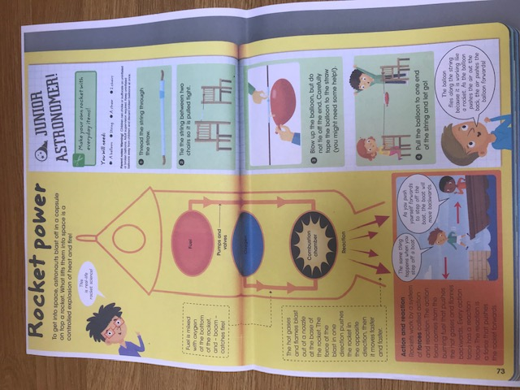

Good luck with your mission. Can you write up what you did, what equipment you used, how you set it all up and how it went. What would you do differently next time and what have you learnt?

