Monday 20th April

English
This is day 1 of the Hamilton Trust website for English. This has reading, grammar and writing activities for each day. Try what you can for each day.
Maths
Use the Year 5 workbook (with answers) or go to
https://whiterosemaths.com/homelearning/year-5/
This website has a whole week of lessons set out, with guidance and answers.
Other
Design and make your own board game – can it be Space inspired? Can you base it upon another board game eg snakes and ladder but with aliens and rockets? Could it have questions or true and false cards? When it is designed and made, play it with your family and see if it works.

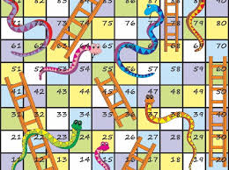
Tuesday 21st April

English
Day 2 with reading, grammar and writing activities.
Maths
Use the Year 5 workbook (with answers) or go to
https://whiterosemaths.com/homelearning/year-5/
This website has a whole week of lessons set out, with guidance and answers.

Other
Art – make a picture inspired by Van Gogh’s Starry Night. How could you make your own night picture with stars?

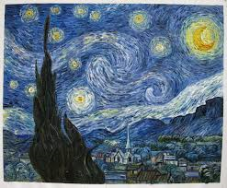
Wednesday 22nd April

English
Day 3 with reading, grammar and writing activities.

Maths
Use the Year 5 workbook (with answers) or go to
https://whiterosemaths.com/homelearning/year-5/
This website has a whole week of lessons set out, with guidance and answers.

Other
Science - https://www.bbc.co.uk/bitesize/topics/z4339j6/articles/zx8hhv4
Look at this BBC Bitesize video clip and read about different types of materials and their properties. Then try to find 4 different examples of each material in your house. Put them into the grid below or draw the grid into your exercise book.

Thursday 23rd April Happy Birthday Finnian

English
Day 4 with reading, grammar and writing activities.
Maths
Use the Year 5 workbook (with answers) or go to
https://whiterosemaths.com/homelearning/year-5/
This website has a whole week of lessons set out, with guidance and answers.

RE

Friday 24th April Happy Birthday Matty

English
Day 5 with reading, grammar and writing activities
Maths
Use the Year 5 workbook (with answers) or go to
https://whiterosemaths.com/homelearning/year-5/
This website has a whole week of lessons set out, with guidance and answers.

Other

We also ask that you look at these practical ideas for other fun activities.
Here is a fun multiplication grid game that you could use as a Maths starter or fun fill in activity.

PE – use Joe Wicks at 9am every morning to keep your fitness levels going or try some online yoga or just dance online.

Science materials Grid
Put an example for each item and try to say what that object is made of that material eg saucepan is metal because it conducts heat and helps to cook the foods in it.
 | Item 1 | Item 2 | Item 3 | Item 4
Metal

Plastic

Glass

Wood

Fabric

