Friday 1st May 2020 (up to 45 mins)
LO: To describe and show understanding of religious sources, beliefs, ideas, feelings and experiences,
concerning the conversation of Paul.
SC: I can make links making links between religious sources, beliefs, ideas, feelings and experiences,
concerning the conversation of Paul.
I can reflect on what the coming of the Holy Spirit means to us in our daily lives as Christians.
Self-Assessment - My understanding: I felt:

Saul is Transformed by the Holy Spirit.
Background Information
Recall and share this story which was previously covered in Year 4 – New Life Topic.
Paul was originally called Saul. He was a Jew who came from Tarsus.
In the Acts of the Apostles, Paul explains what happened to him and how he was converted.
Read ‘The Conversion Of Paul.’ (Acts 22: 6-16)
As I was travelling and coming near Damascus, about midday a bright light from the sky flashed suddenly round me. I fell to the ground and heard a voice saying to me, “Saul, Saul! Why do you persecute me?”

“Who are you, Lord?” I asked. “I am Jesus of Nazareth, whom you persecute,” he said to me. The men with me saw the light but did not hear the voice of the one who was speaking to me. I asked, “What shall I do, Lord?” and the Lord said to me, “Get up and go into Damascus, and there you will be told everything that God has determined for you to do” I was blind because of the bright light, and so my companions took me by the hand and led me into Damascus.

In that city was a man named Ananias, a religious man who obeyed our Law and was highly respected by all the Jews living there. He came to me, stood by me, and said, “Brother Saul, see again!” At that very moment I saw again and looked at him. He said, “The God of our ancestors has chosen you to know his will, to see his righteous Servant, and to hear him speaking with his own voice. For you will be a witness for him to tell everyone what you have seen and heard. And now, why wait any longer? Get up and be baptised and have your sins washed away by praying to him.”

Reflect on the text and discuss the following questions (no need to write anything down):
- What do you think about Saul’s story? Does anything surprise you?
- How do you think Saul felt when Jesus asked him ‘why do you persecute me’?
- Why did Ananias ask Saul to become baptised?
- How was Saul transformed by the Holy Spirit?

Task:
- Look at the painting Fra Angelico’s ‘The conversion of Saul’. Think about how the artist has shown the transformation that has taken place and the effect that it had on Saul.
- Make links between the painting and the scripture Acts 22: 6-16.
- Record your reasons on a grid like this or similar.
In the scripture it says… | On the picture it shows… | I think this because…
Notice that in most paintings about the conversion of Paul depict a horse, which is not recorded in scripture.
Extra activity: Reflect and discuss what you think the ‘Come Holy Spirit’ prayer means for Christians in their daily lives. You could write out this prayer and decorate with appropriate illustrations. Could you share this prayer with your family and learn it leading up to Pentecost?

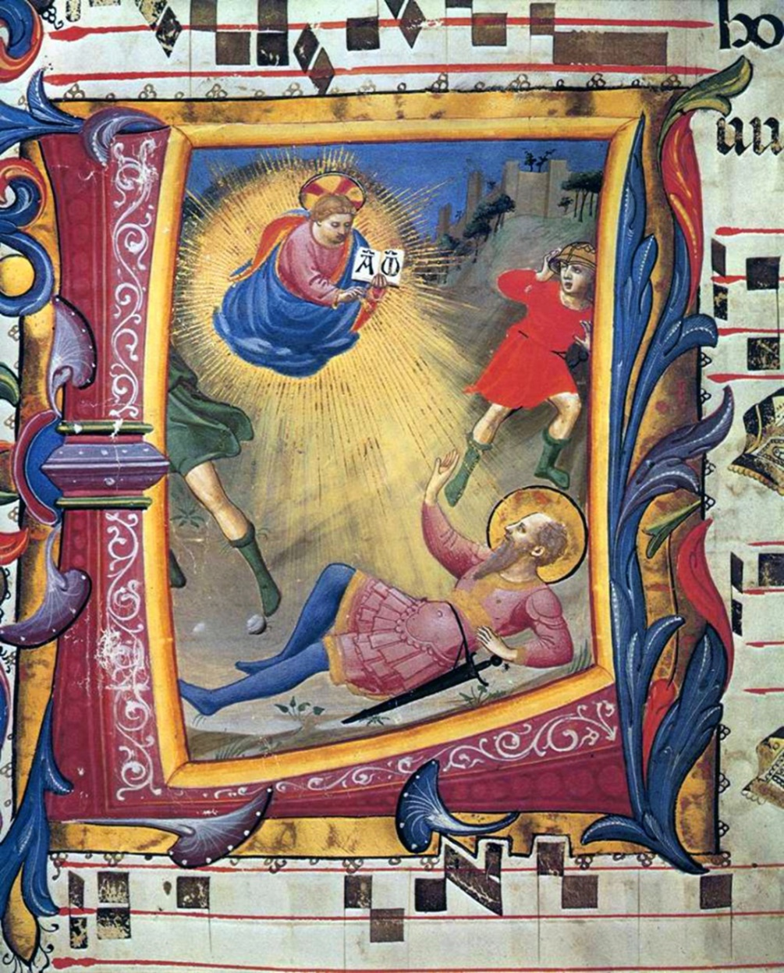
Conversion of Saul By Fra Angelico

Come Holy Spirit,
fill the hearts of your faithful
and kindle in them the fire of your love.
Send forth your Spirit,
and we shall be created and you shall renew
the face of the earth.

