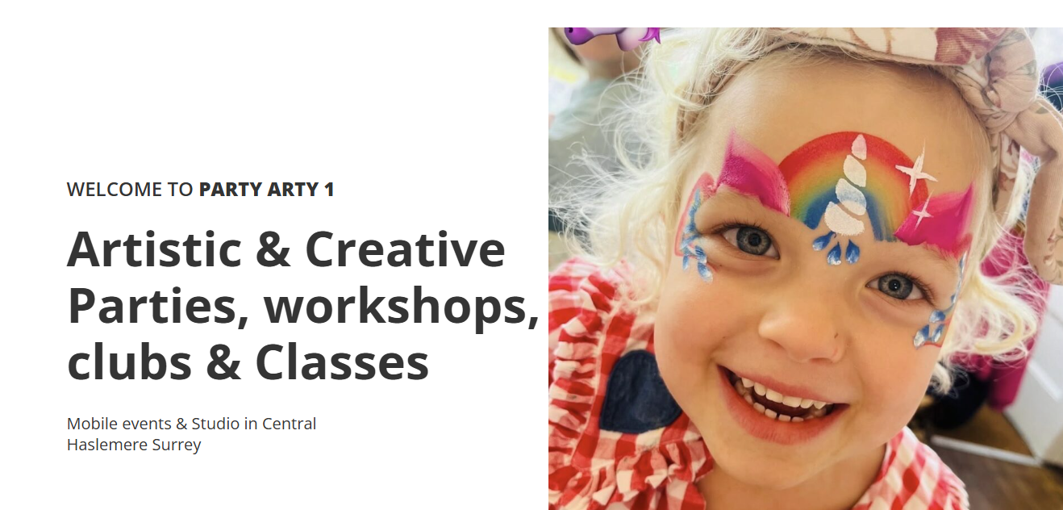

Here is the link for more information:
https://party-arty-1.pembee.app/

